**Microprocessor and Computer Architecture**

**UE21CS251B**

**4th Semester, Academic Year 2022-23**

Date:

|  |  |  |
| --- | --- | --- |
| Name: Nihal T M | SRN: PES2UG21CS333 | Section: F |

Week#____3_______ Program Number: ____1__

Title of the Program

**Generate Fibonacci Series and store them in an array.**

1. ARM Assembly Code

code:

@ generate fibonacci series and store them in an array

.text

ldr r2,=fib

mov r0,#0

mov r1,#1

str r0,[r2]

add r2,r2,#4

str r1,[r2]

mov r4,#8

loop:

add r3,r0,r1

add r2,r2,#4

str r3,[r2]

mov r0,r1

mov r1,r3

subs r4,r4,#1

bne loop

.data

fib:.word 0,0,0,0,0,0,0,0,0,0

1. Output Screen Shots (One)

Output is along memory location: 0000112c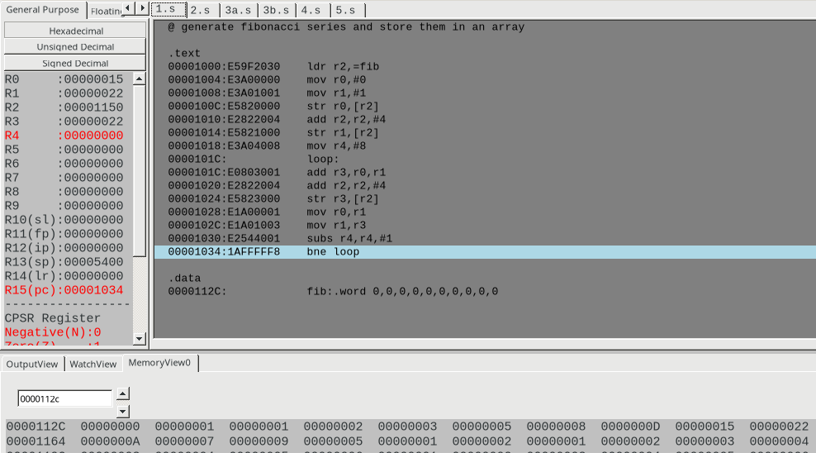

Week#____3_______ Program Number: ____2___

Title of the Program

**Write an ALP to find smallest number in an array of n 32-bit numbers**

1. ARM Assembly Code

code:

@ find the smallest nummber in an array os 32 bit numbers

.text

ldr r4,=arr

ldr r1,[r4],#4

mov r2,#9

loop:

ldr r3,[r4]

cmp r3,r1

bmi swap

add r4,r4,#4

subs r2,r2,#1

bne loop

b end

swap:

mov r1,r3

b loop

end:

mov r0,r1

swi 0x02

swi 0x00

.data

arr:.word 5,2,5,3,10,7,9,5,1,2

1. Output Screen Shots (One)

data array present in 000010f0 memory:

1 is the smallest element in the array is stored in r0 at the end of the program.

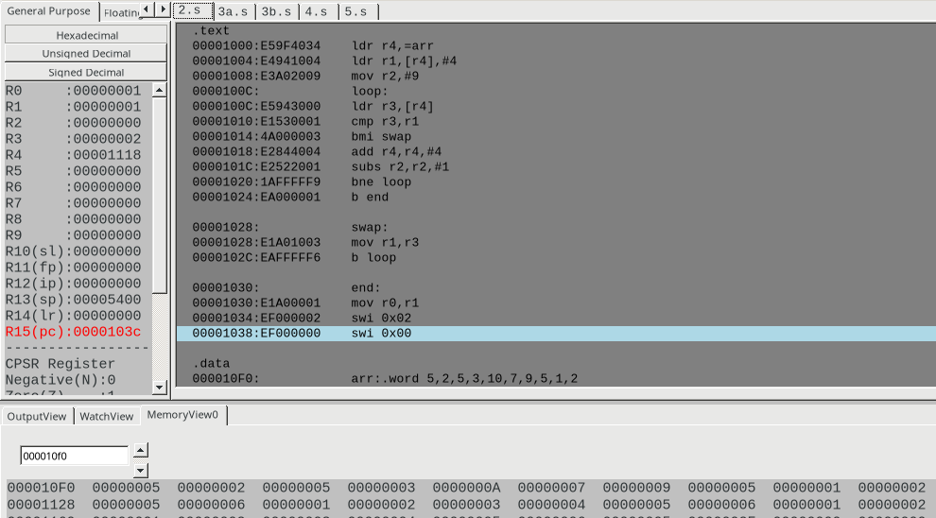

Week#____2_______ Program Number: ____3__

Title of the Program

**To perform Convolution using MUL instruction (Addition of multiplication of respective numbers of loc A and loc B)**

1. ARM Assembly Code

code:

@ Perform convolution using mul instruction

.text

ldr r0,=a

ldr r1,=b

mov r2,#6

loop:

ldr r3,[r0],#4

ldr r4,[r1],#4

mul r5,r3,r4

add r6,r5,r6

subs r2,r2,#1

bne loop

swi 0x11

.data

a:.word 1,2,3,4,5,6

b:.word 1,2,3,4,5,6

1. Output Screen Shot (One)

output is present in r6 register and is displayed in unsigned decimal to enable ease of correction

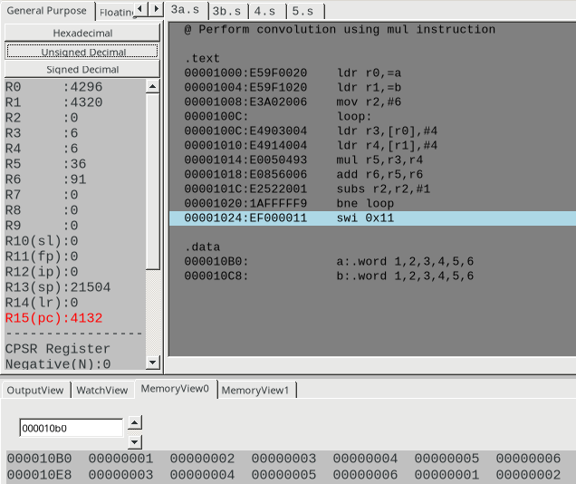

Week#____2_______ Program Number: ____4___

Title of the Program

**To perform Convolution using MLA instruction (Addition of multiplication of respective numbers of loc A and loc B).**

1. ARM Assembly Code

code:

@ doing the same as 3a but by using mla instruction

.text

ldr r0,=a

ldr r1,=b

mov r2,#6

loop:

ldr r3,[r0],#4

ldr r4,[r1],#4

mla r5,r3,r4,r5

subs r2,r2,#1

bne loop

swi 0x11

.data

a:.word 1,2,3,4,5,6

b:.word 1,2,3,4,5,6

1. Output Screen Shot (One)

output is present in r5 register and is displayed in decimal to enable ease of correction.

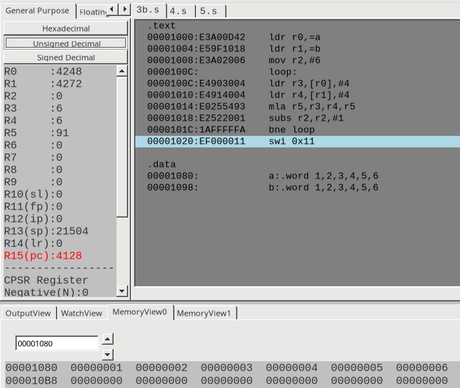

Week#____2_______ Program Number: ____5__

Title of the Program

**Write an ALP to find mul (add( a,b),c)**

1. ARM Assembly Code

code:

@ program to find mul(add(a,b),c)

.data

a:.word 10

b:.word 15

c:.word 7

res:.word 0

.text

ldr r1,=a

ldr r2,=b

ldr r3,=c

ldr r4,[r1]

ldr r5,[r2]

ldr r6,[r3]

add r7,r4,r5

mul r8,r7,r6

ldr r9,=res

str r8,[r9]

swi 0x11

.end

1. Output Screen Shot (One)

output is present in r8 register and is displayed in decimal. It is also stored into memory.

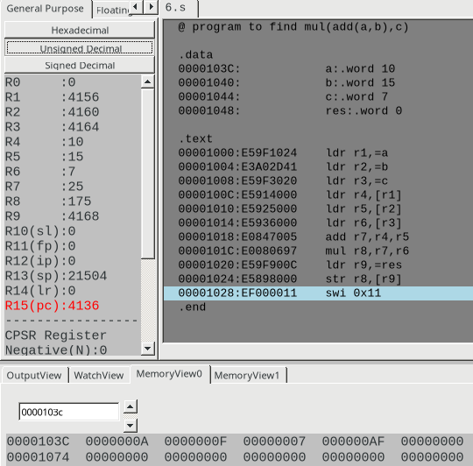

Week#____2_______ Program Number: ____6__

Title of the Program

**Write an ALP to find factorial using subroutine**

1. ARM Assembly Code

code:

@ Find the factorial of a number using subroutine

.text

ldr r0,=n

mov r1,#1

ldr r3,[r0]

bl fact

swi 0x11

fact:

mov r2,r1

mul r1,r2,r3

subs r3,r3,#1

bne fact

mov pc,lr

.data

n:.word 5

II. Output Screen Shot (One)

output is present in r1 register and it is in decimal:

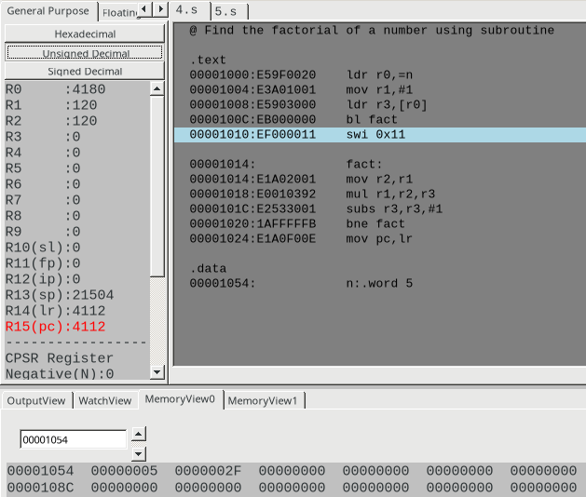

Week#____2_______ Program Number: ____7__

Title of the Program

**Write an ALP to perform multiplication using shift method (without using MUL)**

1. ARM Assembly Code

code:

@ Perform multiplication using shift method without using the mul operation

@ here let us multiply the data num with the number 135

.text

ldr r0,=num

ldr r1,[r0]

rsb r2,r1,r1,LSL #3

mov r3,r1,LSL #7

add r4,r2,r3

ldr r5,=res

str r4,[r5]

swi 0x11

.data

num:.word 47

res:.word 0

II. Output Screen Shot (One)

output is present in r4 register and is displayed in decimal

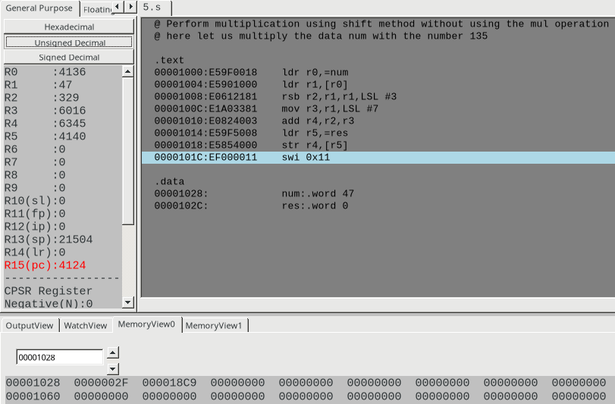

**Disclaimer:**

* The programs and output submitted is duly written, verified and executed by me.
* I have not copied from any of my peers nor from the external resource such as internet.
* If found plagiarized, I will abide with the disciplinary action of the University.

Signature:

Name: Nihal T M

SRN: PES2UG21CS333

Section: F

Date: 31/01/2023